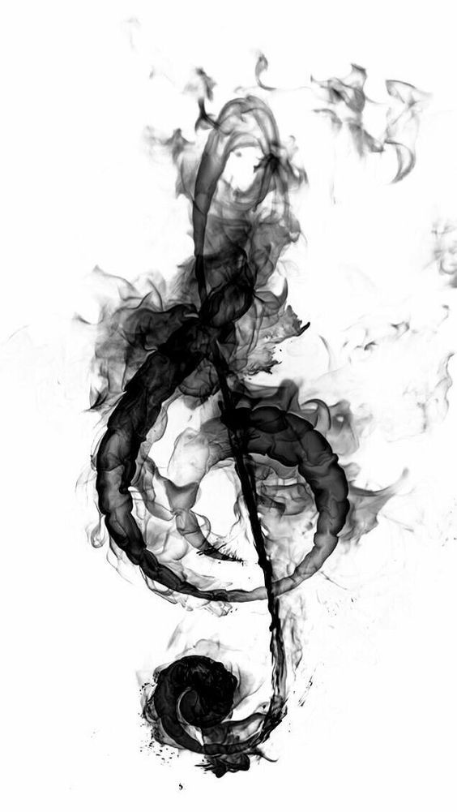
Juanita High School
Choral Department Handbook
2022-2023

Welcome to the JHS Choral Department!

Please take time to read the entire handbook.
Students are responsible for all information in this handbook.

Mrs. Tatiana Boggs - Choral Director
Main Office - (425)936-1600
Email: tboggs@lwsd.org

“There is no doubt that creativity is the most important human resource of all. Without creativity, there would be no progress, and we would be forever repeating the same patterns.”
– Edward de Bono

Welcome to the JHS Choral Program!

September 6, 2022

Dear Singers and Parents/Guardians:

It is my pleasure to welcome you to the 2022-2023 school year at Juanita High School. My name is Tatiana Boggs and I am excited to be at Juanita High School for my fifth year as a public educator! I am looking forward to working with the students at Juanita High School and continuing to grow alongside my students.

I have my B.A. in Vocal Performance from Whitworth University, my M.M. in Vocal Performance from Central Washington University, and my WA State Teacher Certification with an endorsement in Choral Education from Central Washington University. I love music and arts and I strongly believe they have a place in everyone’s life to some capacity.

Please keep this handbook as a reference for the year. In it you will find an overview of our program, information regarding the choir uniform, an explanation of our grading criteria, rehearsal/classroom expectations, information about choir leadership positions, a calendar of choir events, and the JHS Choir Contract. Please take some time to familiarize yourself with this material.
You can also find up-to-date calendars, photos, videos, and news on Teams/OneNote.

My goals as an educator are to provide my students a meaningful education with practical tools that are applicable and transferable to their lives outside of the classroom and after high school. I hope to guide them to develop exceptional musical literary, learn the fundamentals of the choral arts, and effectively and artistically communicate with and understand the music language.

My hope is that students learn to fully appreciate themselves by discovering their capabilities and to develop a self-confidence, a strong sense of community and a deeper appreciation for learning.
I appreciate your support and cooperation and I am looking forward to a wonderful year!

Sincerely,

Tatiana Boggs
tboggs@lwsd.org

JHS Choirs

Jazz Choir (Period 0)

Auditions are held the first week of school each year. Although auditions are open to all students, priority is given to students currently enrolled in choir, band, or orchestra. This course is designed for advanced music literacy in the jazz style of music. This ensemble typically requires more outside performances than Concert Choir. This course may be repeated for credit.

Concert Choir (Period 3)

This course is designed for beginning to intermediate music literacy in choral/vocal music. Emphasis is on tonal production, posture, breath support, intonation, and ensemble unity, while gaining a basic understanding of music reading and theory. Performance literature includes but is not limited to sacred, folk, pop, and patriotic, depending on the season, audience, and ensemble readiness. This course may be repeated for credit.

Concert Choir/Jazz Choir Uniform

In efforts to foster inclusion and promote positive body and identity image for all students our dress code for performances is as follows:

All Black Dress Code

Tops: Black shirts or blouses. Sleeve length should be between the bicep and wrist.
Bottoms: Pants or below-knee or longer skirt with black tights or hose underneath. Black should go all the way to the shoe.
Shoes: Black, close-toed shoes with black socks or tights. Avoid stripes or markings that draw attention.
Jazz Choir: Add accents of red.

Examples:

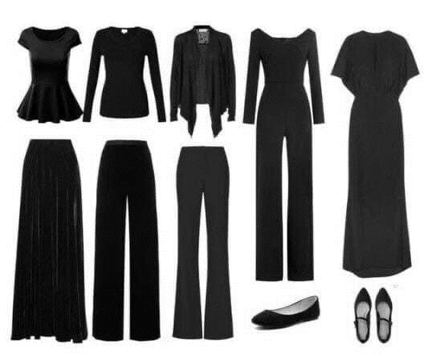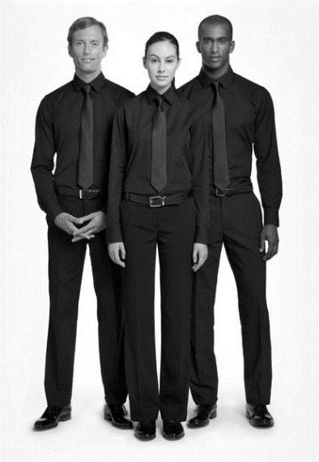

Uniform Guidelines
- Keep hair out of your eyes. Hair clips, ponytails, buns, headbands are acceptable. Please avoid brightly colored hair accessories.
- No dangling earrings or large, noticeable ear gauges. Noticeable body piercings should be removed for the concert (particularly large nose, cheek, or lip piercings).
- Jewelry is acceptable but should not be large enough to pull focus away from the group. Nothing bigger than a quarter should be visible to the audience.
- Wear deodorant, but don’t wear perfume or cologne. Many people are allergic or sensitive to these scents.
- Make sure your concert clothes have been washed and are free or wrinkles for each performance.

Choir Supplies List
JHS Choir Folder (one will be provided for you)
Water Bottle
Pencil
Lined Notebook Paper
Music- each student will be assigned copies to store in their choir folder
Formal Uniform (see Uniform pages)
Choir T-Shirt (Optional)

Grading Criteria

Student achievement will be based on teacher evaluation of attendance at performances, daily participation and responsibility for all rehearsals, preparation of assigned repertoire, and effort toward and mastery of written work.

Grades will be weighted thus:

- Rehearsals/Attendance/Participation: 40%
- Performances: 30%
- Sight Singing/Part Tests: 20%
- Concert Reflections/Written Assignments: 10%

Rehearsals/Attendance/Participation
Daily participation and use of rehearsal time will factor into this portion of a student’s grade. See “Classroom Expectations” and “Rehearsal Etiquette” for more info.

Performances
Concert performances are an extremely important culmination of the work and musical development achieved during our class time. They are the most effective way to demonstrate learning as a choir. As such, attendance is required for set-up, the concert, and striking the set. In the case of a rare extenuating circumstance that would inhibit attending a performance, Mrs. Boggs must receive an email or a signed note from the student’s parent/guardian at least 2 full weeks before the event. If the absence is reasonable AND is not part of a pattern of concert absences, the concert grade may be waived and a make-up assignment offered.
If transportation is an issue, it is the student’s responsibility to find alternate transportation.
Full concert attire, punctuality and clean-up is required for maximum points.
MAKE NOTE OF ALL PERFORMANCE DATES – THEY ARE REQUIRED.

Sight Singing/Part Tests:
Students will be evaluated on their ability to: 1) Sight sing new music to an appropriate level and 2) Effectively prepare and demonstrate their individual parts. More information will be given in class.

Concert Reflections/Written Assignments:
Students will complete a written reflection after each performance. Students will also be given occasional music theory assignments to continue developing a well-rounded musical foundation. Most if not all assignments will be related to the repertoire being rehearsed/performed.

EXTRA CREDIT:
Students who attend a musical performance (outside of the performances they are in), complete a one-paragraph written reflection, and bring the performance program to Mrs. Boggs will receive 5 points extra credit. Reflection questions will be provided by Mrs. Boggs.

Classroom Expectations

- Be ON TIME:
You must be in your assigned spot 2 minutes after the bell. Unless you have a late slip from the attendance office, if you are not ready to sing by the time Mrs. Boggs starts warm-ups then you will be considered tardy.
- Be PRESENT:
Being present means that you mentally prepare to focus on what we are doing in rehearsal and to leave everything else at the door. Cellphones will be silenced and put away during rehearsal.
For performances, students are expected to arrive at the agreed upon call time.
- Be PREPARED:
Always have your music, a pencil and water with you in rehearsal. Prepared also means coming into rehearsal and performances with your music learned. Students are expected to practice their individual part outside of rehearsal.
- Be COOPERATIVE:
Being in choir means collaborating with your peers to work together to achieve a unified sound. It requires high levels of teamwork and cooperation. We will learn together how to best work in groups and how to give constructive and tactful feedback.
- Be RESPECTFUL:
Respect yourself, your peers, your teacher, the classroom and the music. Only one person should be talking at a time. Keep side conversations to a minimum. Creating music can, for some, be a vulnerable experience. Remember to remain respectful when critiquing someone’s performance. We will perform a variety of music and it is expected that every piece will be treated with respect. Respect also includes good communication! Know when to ask appropriate questions or give suggestions. Always communicate questions, absences, or conflicts in a timely manner.
- Be YOU:
Choir is a place where everyone is safe and should feel like they can be true to themselves. You and your gifts are unique and valuable to the world AND TO THIS CHOIR. If everyone contributes fully, we can achieve high success!
Rehearsal Etiquette

Positive Attitude - Come to class ready to focus, work, and make music. Realize that making music is a learning process! It will NEVER be perfect the first time (and rarely perfect the last time). Stay positive and keep working hard.

Posture - In choir, your body is your instrument. Use it properly for singing. When you stand, feet should be slightly separated, weight balanced evenly, arms at sides, and face engaged. When you sit, sit up tall.

Supplies - It is critical that you have your music in a black binder, and a pencil at every rehearsal. You may also wish to bring a water bottle.

Concentration - The best rehearsals move quickly. To accomplish this, every member must be paying attention. Even when your section isn’t singing, you should be following along in your music, ready to jump back in!

Water/Bathroom - When members of our choir are absent, it affects our sound. It is important that students come to rehearsal every day! Leaving class frequently for water/bathroom is a disruption to our rehearsal. Do your best to take care of personal errands during passing time.

Talking - Please raise your hand. Talking out distracts you and everyone else, including your teacher. Choir rehearsals are for singing! There will be a time and place to talk with your peers!

Concert Etiquette

As performers:
  - Arrive at the pre-determined call time.
  - Remain silent while moving on and off the risers.
  - Keep your knees slightly bent so you maintain good blood flow and circulation.
  - Keep your hands rested at your side.
  - Emote the message of the piece with your facial expression.
  - Interact with your peers and the audience while keeping an eye on the conductor.
  - Smile in between pieces at the audience.
  - Reserve interaction with the audience for before and after the performance.
  - Help with setup and take down of equipment. More hands make lighter work.

As audience members:

  - Remain seated during the performances. If you need to leave the performance area, try to do so in between songs during applause. Exceptions would be the calming of a crying child or a coughing attack.
  - Try to remain quiet during the performance to demonstrate respect to the performers.
  - Silence all electronic devices. If taking pictures, please turn off the flash as it distracts the singers from their performance.
  - It is appropriate to clap when the ensemble enters.

Choir Leadership

Giving students the opportunity to develop leadership skills is one of the goals of the JHS choral program. Student leaders play a vital role in the success of any choral program and the positions are taken very seriously. Students who apply for and are elected as leaders are expected to serve as examples for all our students. This is done through rehearsal etiquette, general attitude, and overall involvement in the program. Student leaders represent the choral program at all times and therefore should consistently display the core values of JHS and the choral program. Leadership roles will be selected through a voting process. Mrs. Boggs will make all final decisions regarding leadership positions.

The leadership positions are as follows:
- President: Responsible for coordinating all choir leadership positions, representing the program to the community, scheduling and coordinating all meetings and events, and assisting the Choir Director as needed.
- Vice President: Responsible for assisting the president with all of his/her/their duties, sharing the responsibility of coordinating social events, and assisting the Choir Director as needed.
- Secretary: Responsible for keeping minutes at all officer meetings, taking attendance at meetings and events, uploading and sending out minutes after meetings, regularly updating the Choir calendar, creating “monthly” newsletters, and assisting the Choir Director as needed.
- Public Relations: Responsible for communicating with students, the school and community concerning choir events, assisting the Choir Director with social media content creation and campaigns, coordinating pictures and videos for all choir events, and assisting the Choir Director as needed.
- Social Events Coordinator: Responsible for planning, coordinating and executing all social events for the Choir program, and assisting the Choir Director as needed
- Librarian: Responsible for overseeing all aspects of the choral library. This includes numbering and filing all sheet music, maintaining and organizing the choral library (may require time before/after-school, especially at the start and end of each concert season), and assisting the Choir Director as needed.
- Wardrobe Coordinator: Responsible for informing ensembles of wardrobe requirements for all performances, distributing performance attire when applicable, helping to order/design performance attire and spirit wear when needed, and assisting the Choir Director as needed.

Sectional leaders also play a pivotal role when it comes to the success of a choir. Section leaders are used in all ensembles to increase our ability to learn music and improve as a choir. Section leaders need to be excellent musicians but also have the leadership skills to teach small groups of students. It is expected that section leaders be familiar with all their ensemble’s music before leading their section in learning. They should be prepared to begin warm-ups, lead sectionals or run rehearsals. Piano skills are very helpful in this position (though not required). If you are interested in being a section leader please let Mrs. Boggs know. Mrs. Boggs will select all section leaders.

If you are interested in applying/running for any of the choir leadership positions please see Mrs. Boggs and she will give you an application.

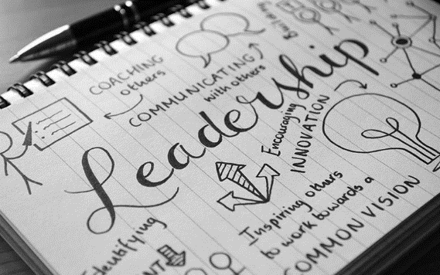

“First Day” Questionnaire

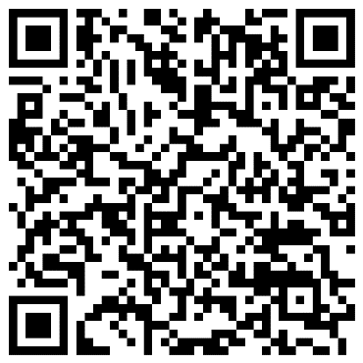

JHS Choir Calendar 2022-2023
(Times and dates subject to change)

All times listed below are performance times. Students will need to arrive at the pre-determined call time, depending on the event. Mrs. Boggs will always get you updated calendars whenever needed! Except where specified, attendance and participation is REQUIRED.

Date | Event | Required for… | Time and Place
September 8 – September 14 | Jazz Choir Auditions | Anybody! | Room 111, JHS
Friday  September 16 | Choir Retreat | All Choirs | 4:00 – 8:00 PM  Room 513, JHS
Wednesday  October 5 | WMEA* All-Northwest Auditions Due | Select students who choose to audition | Auditions scheduled with Mrs. Boggs
Friday  October 14 | Homecoming Football Game  National Anthem | All Choirs | 6:45 PM  FB Stadium, JHS
Tuesday  October 11 | LWSD Honor Choir REHEARSAL | Selected students by audition | 6:30 – 8:30 PM  Choir Room, Redmond
Thursday  October 20 | LWSD Honor Choir REHEARSAL | Selected students by audition | 6:30 – 8:30 PM  Room 513/111, JHS
Monday  October 24 | LWSD Honor Choir REHEARSAL | Selected students by audition | 6:30 – 8:30 PM  Room 513, JHS
Tuesday  October 25 | LWSD Honor Choir REHEARSAL | Selected students by audition | 6:30 – 8:30 PM  LWHS
Tuesday  October 25 | Northlake Jazz Festival** | Jazz Choir | All day  JHS
Tuesday November 1 | Fall Concert** | All Choirs w/  Finn Hill Middle School | Set-up @ 6:00 PM  Call/Warmups @ 6:15  Concert starts @ 7:00 PM  FHMS
Wednesday  November 2 | LWSD Honor Choir REHEARSAL | Selected students by audition | 8:00 – 11:45 AM  Eastlake
Wednesday  November 2 | LWSD Honor Concert | Selected students by audition | 7:30 PM  Eastlake
TBD | Veterans Assembly | TBD | JHS
Wednesday  December 14 | Winter Concert** | All Choirs | Set-up @ 6:00 PM  Call/Warmups @ 6:15  Concert starts @ 7:00 PM  JHS

Date | Event | Required for… | Time and Place
Wednesday  February 8 | Solo & Ensemble Showcase Concert | Solo & Ensemble participants | Time TBD  Theater, JHS
Saturday  February 11 | Northlake Region Solo & Ensemble | Optional to participate | 8:00 AM – 5:00 PM  Redmond High School
Thursday-Sunday  February 16-19 | WMEA* All-Northwest Conference | All-Northwest participants only | Bellevue Hyatt Regency
Wednesday  March 15 | Northlake Choir I Festival | TBD | TBD  Lake Washington
Wednesday  March 22 | Northlake Choir II Festival | TBD | TBD  Inglemoor
Wednesday  April 5 | Spring Concert** | All Choirs | Set-up @ 6:00 PM  Call/Warmups @ 6:15  Concert starts @ 7:00 PM  JHS
April TBD | World’s Finest Chocolate Music Dept. Fundraiser | All Choirs | JHS
Sat-Sun  April 28-29 | WMEA* State Solo & Ensemble Contest |  | Central Washington University
TBD | Testing Make-up Rehearsals | Concert Choir | Time TBD  Room 513, JHS
Wednesday  June 14 | Final Concert | All Choirs | Set-up @ 6:00 PM  Call/warmups @ 6:15 PM  Concert starts @ 7:00 PM  JHS
TBD | JHS Graduation | TBD | TBD

*Washington Music Educators Association
**Denotes parent help needed (usually chaperones); please email me if you’re interested

This schedule is subject to change – your flexibility is appreciated!

Extracurricular Opportunities
Can’t Get Enough Music? I hope you will consider these great opportunities!

- Voice Lessons:
Voice lessons are a great way to improve musicianship and confidence, prepare for solo contest, and get the foundation necessary to pursue music in college. Let Mrs. Boggs know if you are interested and she can help refer students to an instructor.

- Piano Lessons:
Piano is a wonderful way to improve musicianship. Let Mrs. Boggs know if you are interested and she can help refer students to an instructor.

- WMEA All-Northwest: Feb 16-19 in Bellevue, WA
Northwest ACDA Honor Choir: Feb 22-25 in Cincinnati, OH
Students may audition to be part of these honor choirs. Auditions for WMEA All-Northwest are due October 5. Auditions for Norwest ACDA SSAA and SATB choirs are due September 29.

- Solo/Ensemble Contest:
Placement in an ensemble will be largely dependent upon work done in rehearsals throughout the year. Students may work with Mrs. Boggs after school if they choose, but it is not guaranteed Mrs. Boggs will always be available. If students want assistance deciding if they want to perform a solo or choosing a solo Mrs. Boggs can help with this process. Solos should be somewhat prepared before students register for the contest.

- Community Choral Programs:
  - Bellevue Youth Choirs - https://bellevueyouthchoirs.org/
  - Kirkland Choral Society - https://www.kirklandchoralsociety.org/
  - Carillon Chamber Choir - https://www.kampmusic.org/carillon-chamber-choir

- Attend a performance:
One of the best ways to broaden your horizons and learn more about music is to attend performances. We have so many wonderful groups in our area. Consider attending other high school concerts, such as Lake Washington, Redmond, or Eastlake. Many universities in the area also host performances throughout the year. Mrs. Boggs will try to keep students up to date on upcoming performances! There’s a lot of cool music happening in the greater Seattle area – take the opportunity to experience it!

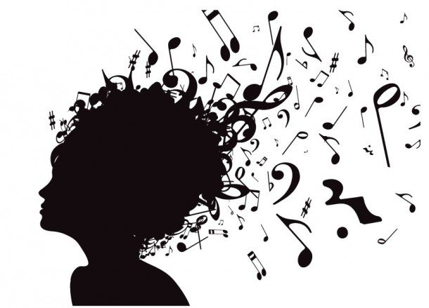

JHS Choir Contract
Due: Friday September 16, 2022

I have read, understand, and will abide by the objectives for Juanita High School’s Choir Program.

Student (Printed)___________________________________________________________________________
Signed ___________________________________________________ Date____________________________
Best E-mail __________________________________ Best phone contact _____________________________

I have read, understand, and am willing to support my child in upholding and working toward the objectives for Juanita High School’s Choir Program.

Parent (Printed)_____________________________________________________________________________
Signed ____________________________________________________Date____________________________
E-mail _____________________________________ Best phone contact_______________________________

I would like you to know this about my child:

Please mark whatever options are true for you:

____ I prefer to receive physical documents from Mrs. Boggs.

____ I prefer to receive documents electronically from Mrs. Boggs.

____ I would love to be a Juanita Booster Club Music Parent REPRESENTATIVE (this involves helping with fundraisers, attending booster club meetings, donation collection at concerts, etc.)
____ I would love to be a Juanita Booster Club Music Parent Volunteer (this involves helping with fundraisers, donation collection at concerts, etc.)

____ I would be happy to volunteer my time or services at some point this year, just let me know what my options are as they come up!

Furthermore, I would like to say:

8.31.2022

